**Ocean One User Manual for Configuration Module**

* **Introduction**

Ocean One is a web application to manage credit Card application process, Personal loan process, Expense management, Attendance records and Payroll management etc

* **Login**

Ocean One allows users to log in using your username and password given to you by the admin.

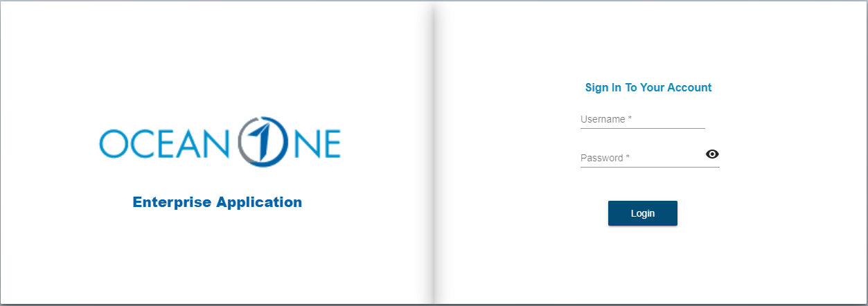

Fig. Login Page

* Enter Username
* Enter Password
* Click on Login

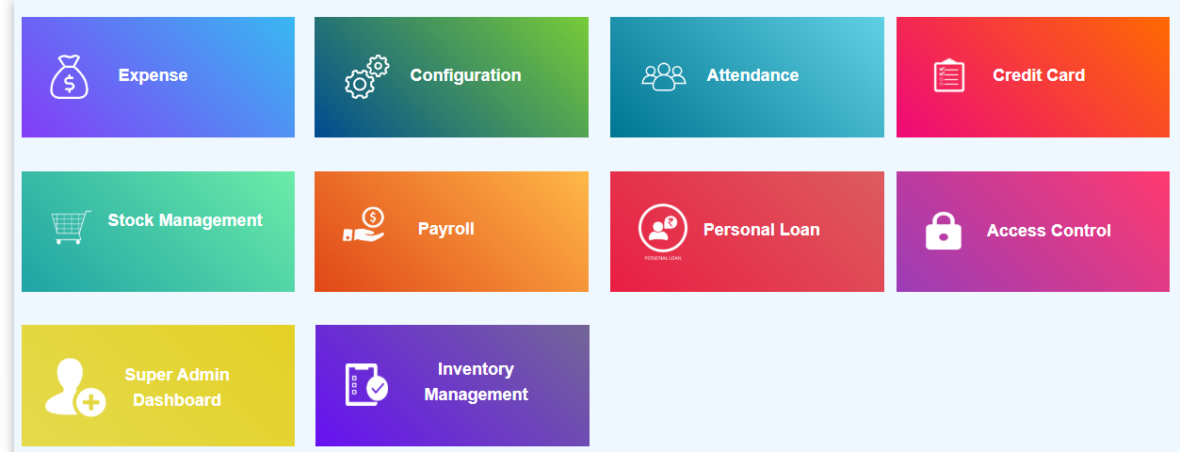

**Fig. Dashboard**

1. **Configuration: -**

* Click on Configuration

In Configuration module admin is able to add new employee but before adding employees he has to add Department, Designation, Offices first.

1. **Department Master: -**

* Click on Department Master

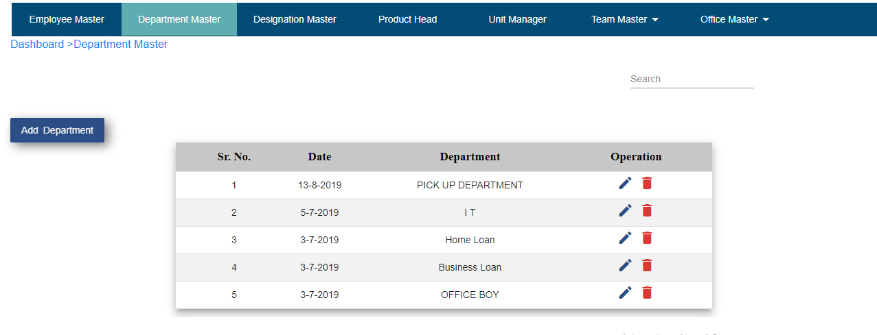**Fig. Department Master**

* Click on Add Department button
* Enter department name.
* Click on create button.
* Record will display in department master table.
* Search field is available if user wants to search department name.
* If user wants to update particular record then click on edit operation.
* Enter department name.
* Click on the update button.
* If user keep department name as it is and click on the update button then “Department name already exist” pop up display.
* If user doesn’t want to update department name then click on cancel button.
* Click on the delete operation to delete particular record.

1. **Designation Master: -**

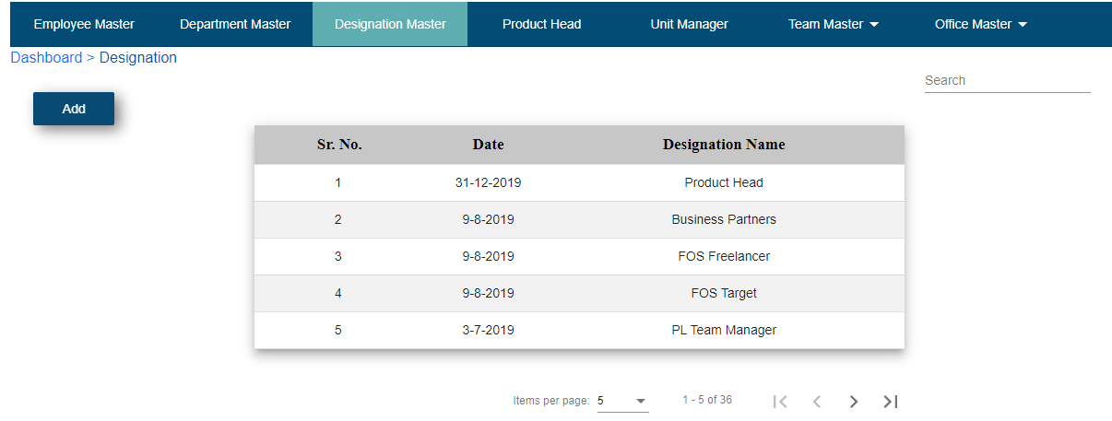

**Fig. Designation Master**

* Click on Designation Master
* Click on Add
* Enter Designation name
* Click on Add
* If you want to cancel entered name then click on cancel

**C) Office Master: -**

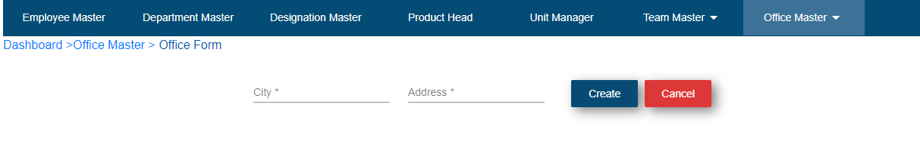

**Fig. Office Master**

**1. Add Office**

* Click on Office Master
* Click on Add Office
* Enter city name.
* Enter address.
* Click on create button.
* Record will show in offices table.

**2. Sub Office**

* Click on Office Master
* Click on Add Sub Office

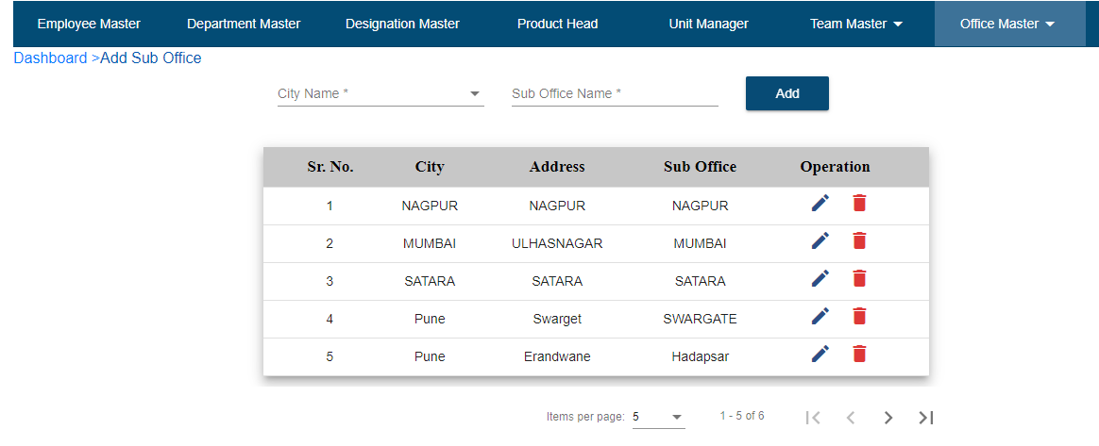

**Fig. Sub Office**

* Enter City Name
* Enter Sub Office Name
* Click on Add
* If User wants to Update Sub Office name then click on edit, enter another name and click on update.
* Click on the delete button to delete particular record.
* If users want to search any record then click on search field.
  1. **Employee Master: -**

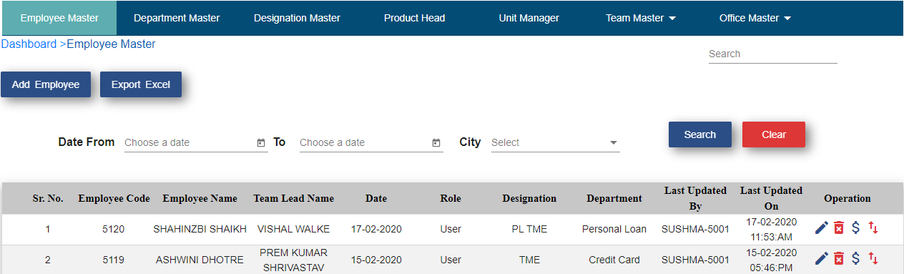

**Fig. Add Employee**

* Click on Employee Master
* Click on Add Employee
* Click on Employee Form
* Enter employee code – User should be able to enter characters, integers, special symbols.
* Enter email id – User should be able to enter email id in “[abc@gmail.com](mailto:abc@gmail.com)”
* Enter first name.
* Enter last name.
* Select role.
* Select designation.
* Select office.
* Select sub office.
* Select In time – HH:MM:AM/PM
* Select Out time – HH:MM:AM/PM
* Select department
* Enter password
* Click on password visibility – User is able to see entered password
* Choose date of joining
* Select process
* Select salary type
* Enter salary
* Bank Name
* Account No
* IFSC Code
* CITI DSR CODE
* ICICI DSR CODE
* HDFC DSR Code
* YES DSR Code
* SCB DSR Code
* RBL DSR Code
* INDUSIND DSR Code
* Hide Salary
* PF and ESIC
* Click on create button

**Note: * indicates all fields are mandatory**

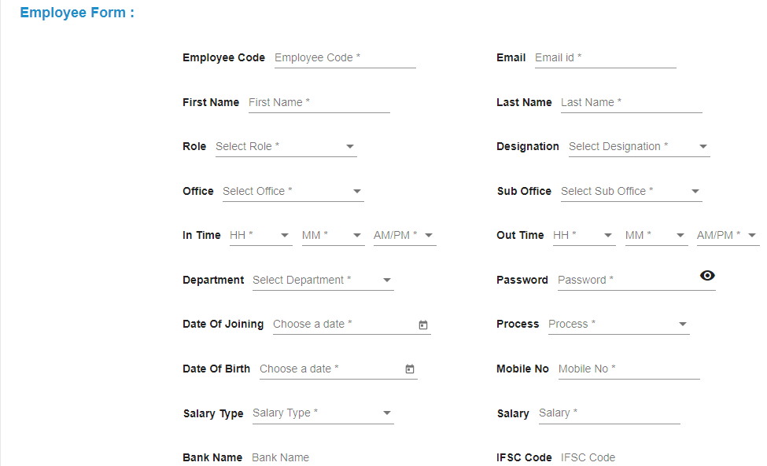

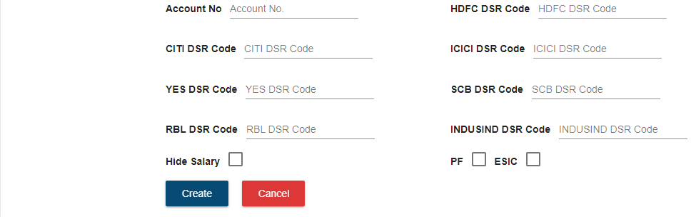

Fig. Employee Form

* Create all employees
* After Creating employee, give access to that employee according to their role
* Go to dashboard
* Click on access control
* Click on search field.
* Search username which admin wants to give access of particular module to that user.
* Click on edit operation.

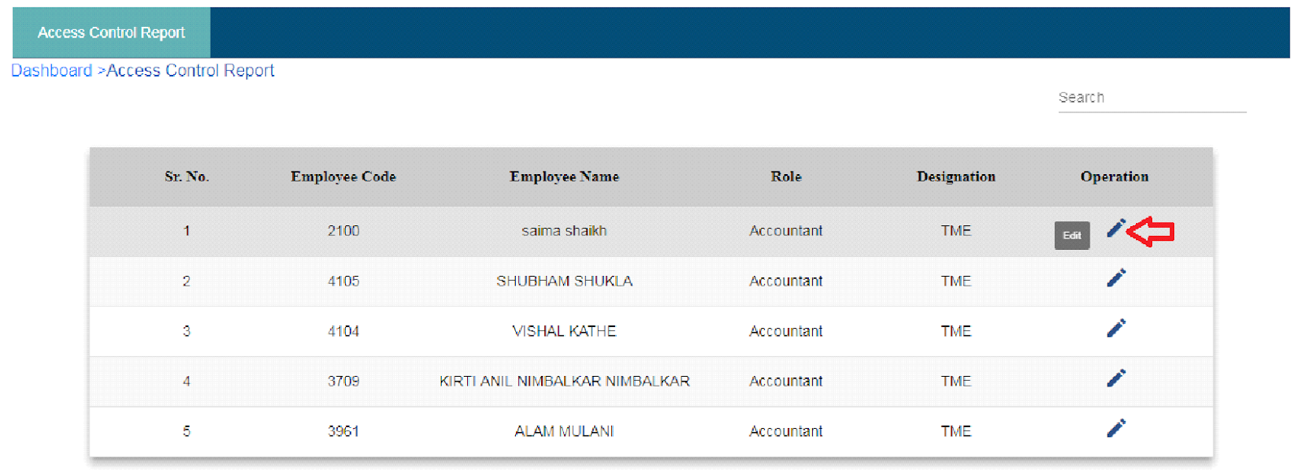 Fig. Access Control

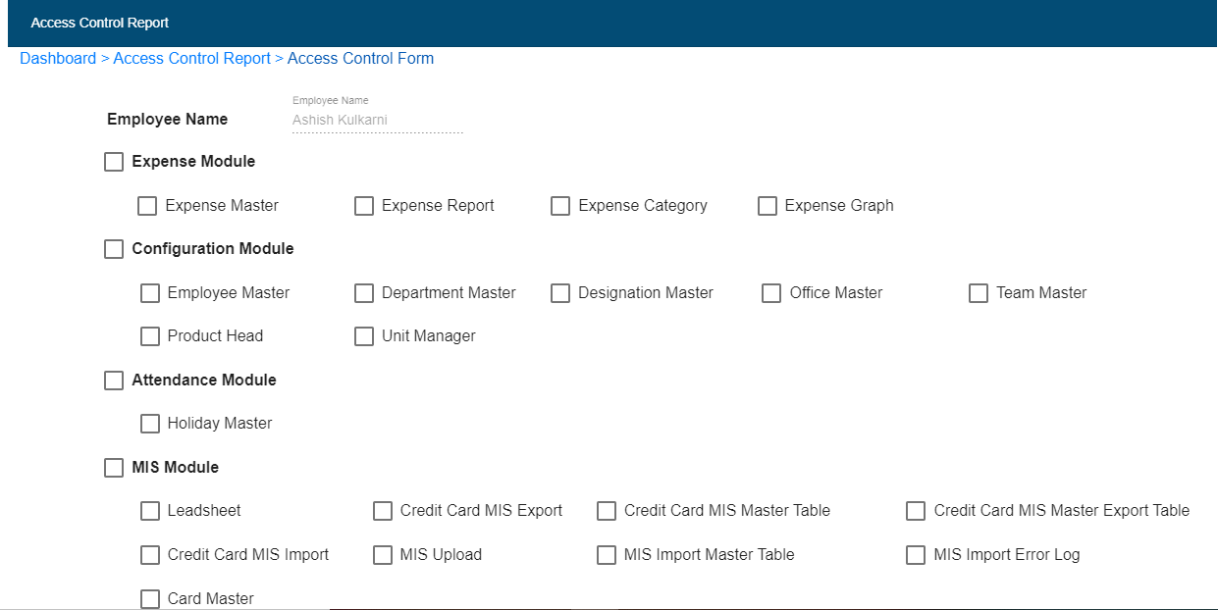

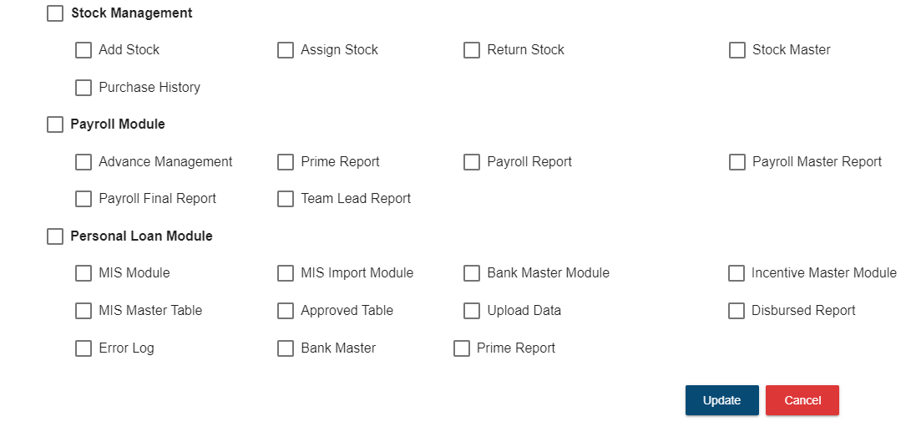

Fig. Access Control Form

* Click on the checkbox of particular module which admin wants to give access to the user.
* Click on the update button.
* Click on cancel button if user wants to navigate back to the access control page.

Then create hierarchy between Product head, Unit manager, Team leader and TME and other members.

* 1. **Product Head: -**
* Click on Product Head

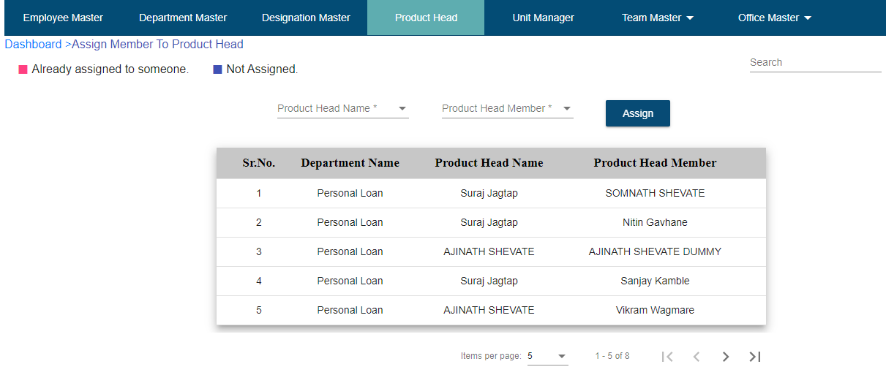

**Fig. Assign product Head to Unit Manager**

* Users who are having designation as “Product Head” will appear in Product Head Name dropdown.
* If user is having designation as “Product Head” and it is not displaying in Product Head Name dropdown it means this user is a Team lead and present in team lead table or User is present in Unit Manager table or user is a member of any team lead, In that case you have to remove all dependencies of that user after that it will be visible in Product Head Name dropdown.
* Select Product Head from dropdown menu
* Select Product Head Member from dropdown which are unit managers
* Click on Assign
  1. **Team Master: -**

After adding PL Team manager or CC Team Leader first add them as Team Lead

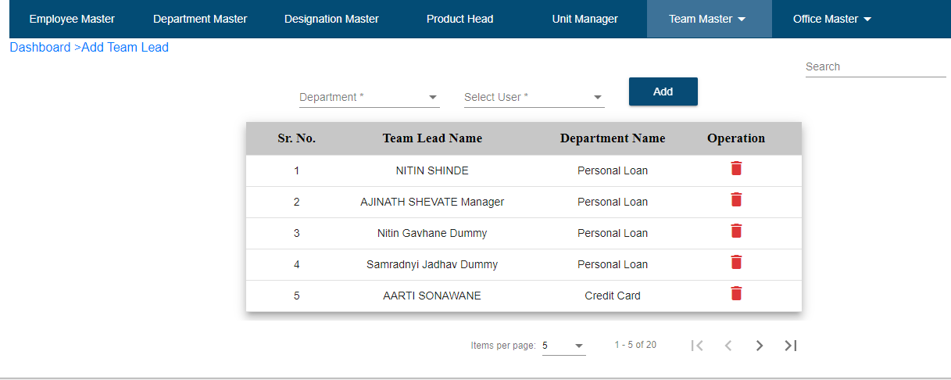

**Fig. Add Team Lead**

**1.Add Team Lead**

* Click on Team master
* Click on Add Team Lead
* Select Department
* Select User
* Click on Add
* If User wants to delete added record then click on delete icon

**2.Assign Team Member: -**

After adding Team lead then assign team member i.e. TME under Team Leader

* Click on Team Master
* Click on Assign Team Member

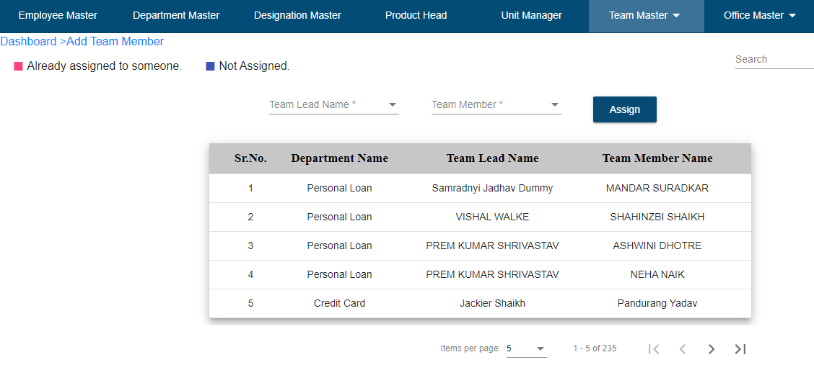

* Select Team Lead Name from dropdown list
* Select Team Member Which are TME
* Click on Assign
  1. **Unit Manager: -**
* Click on Unit Manager

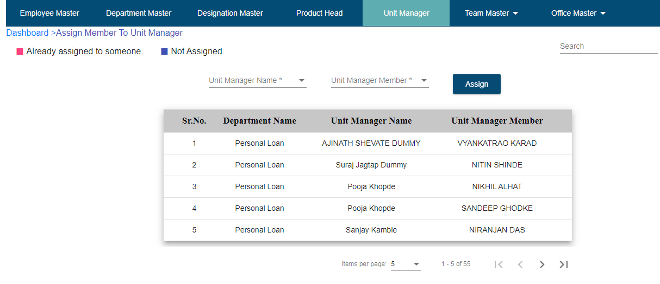

**Fig. Assign Unit Manager to Team Manager**

* Users who are having designation as “Unit Manager” will appear in Unit Manager Name dropdown.
* If user is having designation as “Unit Manager” and it is not displaying in Unit Manager Name dropdown it means this user is a Team lead and present in team lead table or User is present in Product Head table or user is a member of any team lead, In that case you have to remove all dependencies of that user after that it will be visible in Product Head Name dropdown.
* Select Unit Manager Name
* Select Unit Manager Member which are PL Team Manager
* Click on Assign

If Admin wants to download all added employee list then follow below steps –

* Click on Employee Master
* Click on Export Excel
* Click on OK
* Click on OK
* Employee Master Report get downloaded which is shown below

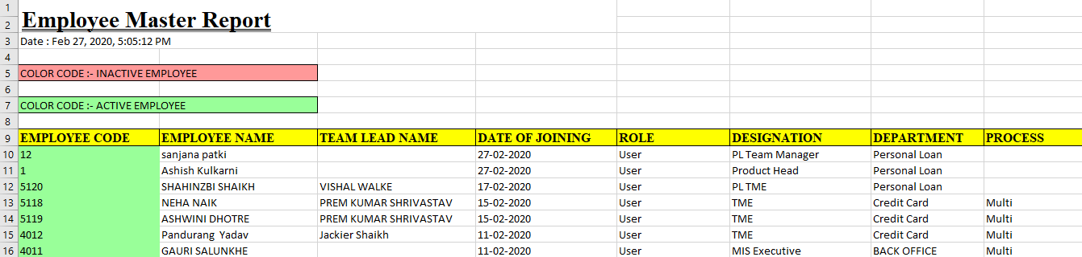

**Fig. Employee Master Report**

User is able to see employees of particular date range and also city wise

* Choose Date From
* Choose Date To
* Select City
* Click on Search



**Fig. Search**